**BSc (Hons) in Information Technology**

**Software Engineering – Year 3 Semester 2, 2022**

**SE3050 – User Experience engineering**

**Milestone 03**

**Team BIKO - SER_027**

IT20142650 Epitakaduwa E.K.G.D

Table of Content

Identification of the fail points …………………………………………………………………………………………………………………………03

* Fail point -01 ……………………………………………………………………………………………………………………………………….05
* Fail point -02 ……………………………………………………………………………………………………………………………………….06
* Fail point -03 ……………………………………………………………………………………………………………………………………….07

User Key flows …………………………………………………………………………………………………………………………………………………08

* Diagram 01 …………………………………………………………………………………………………………………………………………08
* Diagram 02 …………………………………………………………………………………………………………………………………………09
* Diagram 03 …………………………………………………………………………………………………………………………………………10

Identification of the fail points

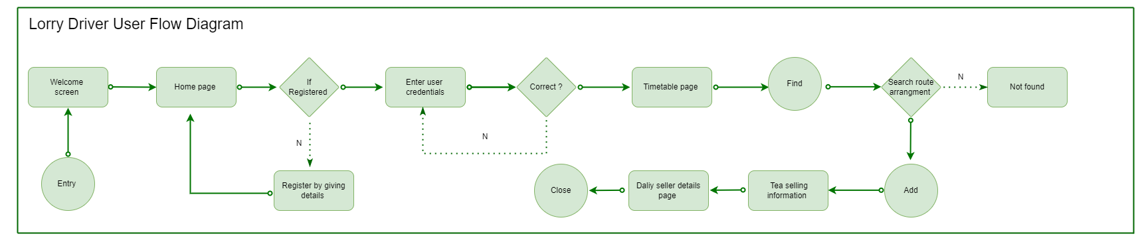

03

02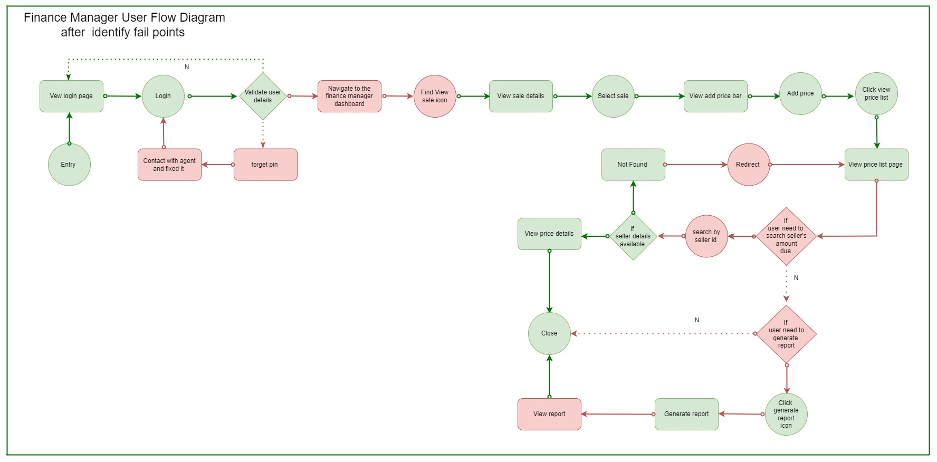

01



04

02

033

02

01

After completing the milestone 2, I have identified several fail points in my user flow.

In the user research, I have identified 04 blockings with referring to the interviews we have done during the user research.

In 1st diagram mentioned above I have highlighted the Fail points that I have found and the 2nd diagram represent the way that I have overcome those fail points.

**Fail point – 01**

The first fail point I have identified in my user flow is, not having a feature to reset the password if the password will got forgotten.

As the lorry driver is a user of the system and I have added an option to change the password by connecting with an agent of the operating side.

**Fail Point -02**



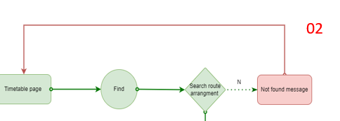

The second fail point I have identified is that , not mentioning the path after not finding the route details.

If the searched route details are not available in the system the process must be redirect automatically to the timetable page again to make a more user friendly experience.

**Fail point – 03**

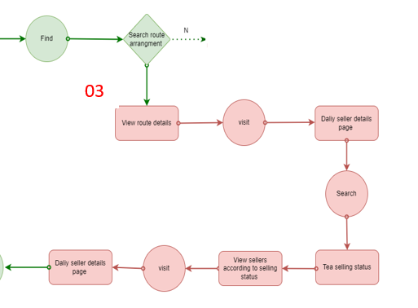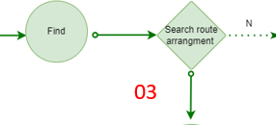

The 3rd fail point of my user flow has been identified by me using the user research I have done. There they mentioned that, the tea sellers inform whether the tea plucking is happening or not on a particular day in the morning. But they do it only via a phone call.

So I have identified that I have to add that feature in to the application as well to get notify from what seller do the driver has to collect tea from. According to the update done by the tea seller by adding a daily status field to the tea seller table I have update my user flow to check that status every day before starting the tea collecting process.

All above mentioned fail points are identified with reference to the user research

Video link: <https://drive.google.com/file/d/1HlYCUV4V60p3liVwTxGapOoMTKrIytiE/view?usp=sharing>

User Key flows

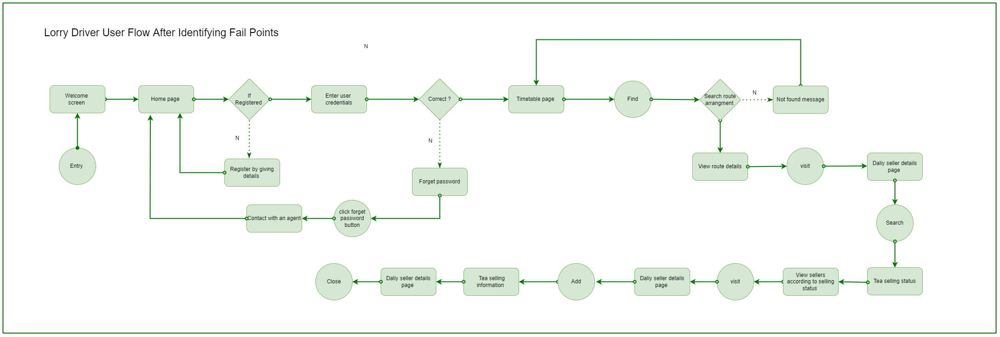

Diagram 01

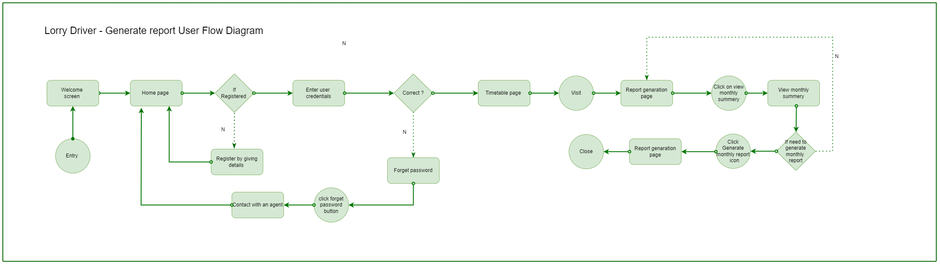

Diagram 02

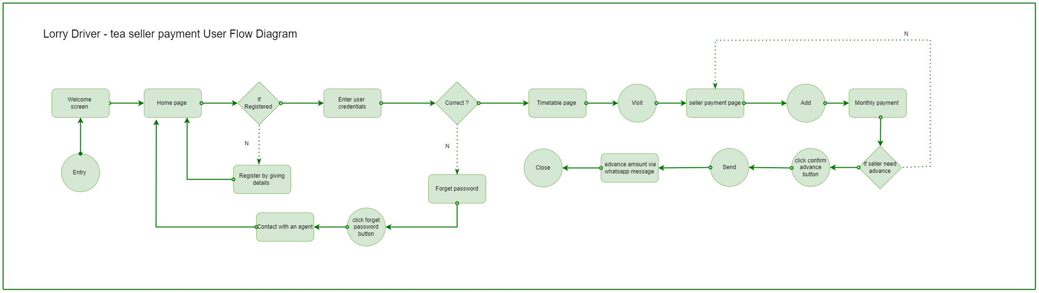

Diagram 03